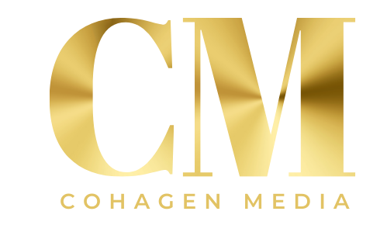
Client Questionnaire:
SEM
- What are the goals/business drivers for all advertising and online specifically? (branding, direct `response, customer acquisition, drive online purchases, drive traffic, competitive move, data gathering etc)
- What metrics do you use to measure the success of the campaign?
- Who are your competitors online and offline?
- What site analytics do you currently use to monitor your web traffic? Do you plan to change in the near future?
- Are you able to see integrated reporting for both paid and natural search?
- What technology platform is used to support SEM bidding and campaign optimization?
- What type of access do you have?
- What regular reports do you receive and what detail is provided in these reports?
- Do you own your accounts with the engines or are they under a master account with your current agency?
- How many keywords are currently managed in your portfolio?
- Do you feel there is room to grow the portfolio and if so in what ways would you want keyword coverage expanded?
- What is the contribution of brand terms and generic terms to traffic and conversions?
- What role does geo-targeting play in your current campaign?
- Are there any current or upcoming promotions we should be aware of?
- What is the relationship and interaction between your traditional Ad agency ( offline, creative etc) and your search agency?
- Are you willing to share historical reports on SEM campaign performance ( engine and keyword level)? If so please attach with response.
- How much do you spend a month approximately on SEM?

SEO
- How do you measure SEO campaign success? Traffic, Conversion (bookings), Rankings, pages Indexed?
- What are/were previous SEO successes/failures and what are some specific future goals you’d like to address?
- Content Creation: Do you think you’ll need additional website content? Do you have someone there who can write content?
- What platform does your site currently operate on?
- Does your site technology produce any known or historic obstacles for implementing SEO best practices?
- What are your current link building efforts?
- What are your 10-20 mission critical keywords?
- How well are you ranked for these terms currently?
- How much do you spend a month to support ongoing SEO services?

Client Questionnaire cont.:

Display / Direct Marketing
- What is your CPA target?
- Please describe how leads (sale/booking) are generated. Please be specific as possible, pages, fields, etc
- Can the campaign be promoted via email, if yes do you maintain a suppression list?
- How long is your window for post impression & post click conversion payouts?
- Confirm page URL – please provide
- Can the registration form or page be hosted?
- What is your average click to conversion ratio?
- Are you running any other acquisition based campaigns, if yes with who?
- How much are you currently spending on lead generation and display advertising?
- Do you have an affiliate marketing program and if so who is your provider?

Emerging Media
- Are you currently running any social media or digital word of mouth campaign?
- Do you currently have any initiatives around blogger relations and blog outreach?
- Are you interested in learning more about emerging media capabilities?

Account Management
- Please describe your current account management team. What attributes do you like and what additional skills or competencies would enhance the relationship?
- How often do you meet with your account team via phone and in person based on a typical quarter?
- How many people are assigned to your program?

Questions?
Please contact:
Tim Lloyd Cohagen
312-818-5656
Tim@cohagenmedia.com

